Date:

From,
Bazit Ullah Badiuzzaman
# Hyatdatdawa Pvt. Ltd
Kilo 14, Jeddah

MAIL- ID : zamanpharma@gmail.com

Mobile No: +966540802696(PER) +919886168915(HOME)

Respected sir,

Sub: - Application for a suitable position at your esteemed organization.

I (Bazit Ullah Badiuzzaman) would like to present myself to work in your esteemed organization in light of my qualification and experience.

I have completed M.Pharm and having a total 3.8 years experience. I firmly believe, qualifies me for the position you are seeking to fill.

In order to apprise you of my detailed academics and experience, I am here by enclosing recent curriculum vitae to your kind perusal.

If given an opportunity to serve in your organization, I will prove myself with best of my abilities and hope to win your faith very soon.

Thanking you sir,

Yours sincerely
Bazit Ullah Badiuzzaman

CURRICULUM VITAE

Bazit Ullah Badiuzzaman  Jeddah, KSA  MAIL- ID : zamanpharma@gmail.com  Mobile No: +966540892696(PER) +919886168915 (HOME)  Passport No. L2699069 | 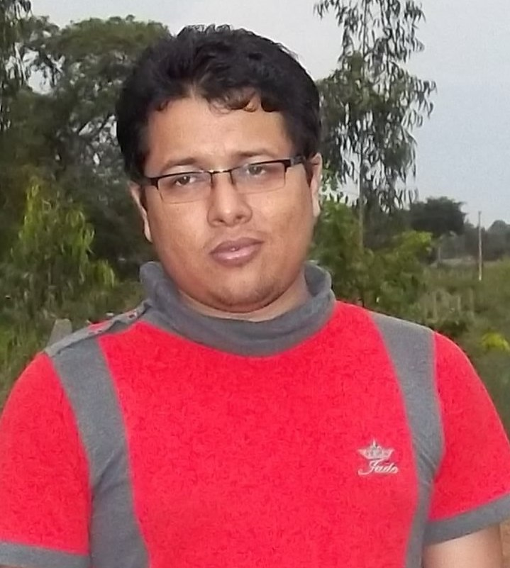

CARRER OBJECTIVE:

A challenging career in Retail Pharmacist/Chain Pharmacist, where I can enhance my knowledge and skill to the best of my abilities and contribute towards the growth of the organization. To innovate and excel, thus be a professional who can make qualitative difference.
EDUCATIONAL QUALIFICATION:

Exam Passed | Name of Institution  University/Board | Year of passing | Grade/ Percentage | Subjects
M.Pharm | National College of  Pharmacy, Shimoga.  Rajiv Gandhi University of Health Sciences (RGUHS)  Karnataka. | 2010-11 | 72.29% | Pharmaceutics
B.Pharm. | S.C.S. College of  Pharmacy, Harapanahalli. (RGUHS)  Karnataka. | 2008 | 62.70%  (aggregate) | Bachelor in Pharmacy
Higher Secondary  (+2) | Juria H.S. School  (AHSEC)  Assam | 2004 | 56.40% | Science (PCMB)

AREAS OF SPECIAL INTEREST:

● Retail Pharmacist/Clinical Pharmacist

DISSERTATION TOPIC

“STUDIES ON DEVELOPMENT OF COLONIC DELIVERY OF COMPRESSION COATED SECNIDAZOLE TABLETS USING NATURAL POLYMERS”

Saudi Licencing Exam

Qualified Saudi Health Authority Exam (Pearson Vue) for Pharmacy specialist with 83% of marks.

PUBLICATION DETAILS

1. My research work has published to journals bearing of title Development and Evaluation of Microbial Degradation Dependent Compression coated Secnidazole Tablets for Colonic Delivery in Indian journal of pharmaceutical science. This article is awarded for best article.
PERSONAL SKILLS:

  - Positive attitude towards the responsibilities.
  - Ready to accept challenges.
  - Can adapt any situations.
COMPUTER SKILLS:

MS.Office & Tally.

PERSONAL INFORMATION:

Fathers Name : Abul Bakhir
Date of Birth : 26.10.1985
Sex : Male

Languages Known : English, Hindi, Assamese, Urdu and Bengali
Marital Status : Married

DECLARATION

I hereby declared that all the above mentioned information is true to the best of my knowledge.

Date:
Place: Bazit ullah Badiuzzaman

